CSD 302

Design and Analysis of Algorithms

Tutorial Problem

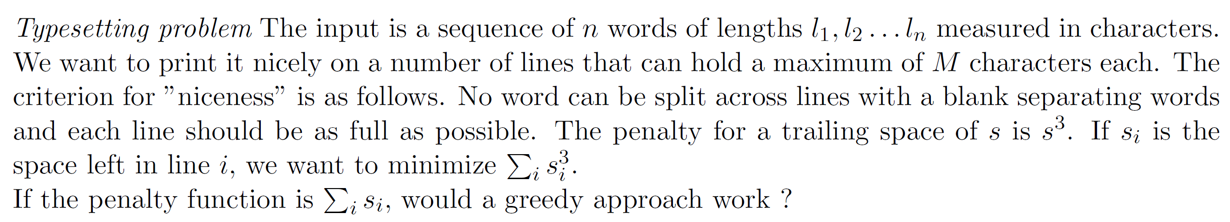
Approach:
Let us look at Greedy:
- Put as many words as possible in the current line
- Then move to the next line and so on.
However, as easy as it looks, it may not work for all cases:
Example:
Let the sequence be “I would like to study for my security quiz”
I | 1
Would | 5
Like | 4
To | 2
Study | 5
For | 3
My | 2
Security | 8
Quiz | 4

Greedily, we get:
I would Empty Spaces: 3
like to Empty Spaces: 3
study for Empty Spaces: 1
my Empty Spaces: 8
security Empty Spaces: 2
quiz Empty Spaces: 6
Total Error = 3³ + 3³ + 1³ + 8³ + 2³ + 6³
= 27 + 27 + 1 + 512 + 8 + 216
= 791

However, a better split could be:
I would Empty Spaces: 3
like to Empty Spaces: 3
study Empty Spaces: 5
for my Empty Spaces: 4
security Empty Spaces: 2
quiz Empty Spaces: 6
Total Error = 3³ + 3³ + 5³ + 4³ + 2³ + 6³
= 27 + 27 + 125 + 64 + 8 + 216
= 467

Hence, we can safely say with this counter example that greedy is not the way to go.
Okay, let’s get on with it.
We can use Dynamic Programming to solve this problem
Let us use the same string and create a table of size n². This (I,j)^{th} entry of this table indicates the cost of storing all the words from I to j in one line, where I and j are indices.
Here is the length table again for reference:
Index | Word | Length
0 | I | 1
1 | Would | 5
2 | Like | 4
3 | To | 2
4 | Study | 5
5 | For | 3
6 | My | 2
7 | Security | 8
8 | Quiz | 4

 | 0 | 1 | 2 | 3 | 4 | 5 | 6 | 7 | 8
0 | 729 | 27 | ∞ | ∞ | ∞ | ∞ | ∞ | ∞ | ∞
1 | - | 125 | 0 | ∞ | ∞ | ∞ | ∞ | ∞ | ∞
2 | - | - | 216 | 27 | ∞ | ∞ | ∞ | ∞ | ∞
3 | - | - | - | 512 | 8 | ∞ | ∞ | ∞ | ∞
4 | - | - | - | - | 125 | 1 | ∞ | ∞ | ∞
5 | - | - | - | - | - | 343 | 64 | ∞ | ∞
6 | - | - | - | - | - | - | 512 | ∞ | ∞
7 | - | - | - | - | - | - | - | 8 | ∞
8 | - | - | - | - | - | - | - | - | 216

The combinations of words that cannot fit into one line are denoted by infinity.
Clearly, all that’s left to do now is to come up with an appropriate recursion. To that end, let us define some notation:
  - C[j] = Optimised total cost for arranging words from 1 to j in lines.
  - S(i,j) = Cost of arranging words I to j in one line

So, the recursion can be defined as follows:
0, if j = 0
C[j]=
Min (C[i - 1]+ S(i , j)), if j>0
^{1 ≤ i ≤ j}

Yes, I guess that’s it.

Space Complexity: O(n²)
Time Complexity: O(n²) + O(n²) [Cost of building matrix + Recursion]
= O(n²)

Greedy for a linear cost function:
- I reckon it should work as the first thing greedy achieves is that it minimised the number of lines used. And since the number of characters in the string are fixed, we should be able to get to an optimal cost without any problem.

